Assignment
Module: 5
Section 1: Multiple Choice

1. What is the primary function of a router in a computer network?
a) Assigning IP addresses to devices
b) Providing wireless connectivity to devices
c) Forwarding data packets between networks
d) Managing user authentication and access control
Ans. c) Forwarding data packets between networks

2. What is the purpose of DHCP (Dynamic Host Configuration Protocol) in a computer network?
a) Assigning static IP addresses to devices
b) Resolving domain names to IP addresses
c) Managing network traffic and congestion
d) Dynamically assigning IP addresses to devices
Ans. d) Dynamically assigning IP addresses to devices

3. Which network device operates at Layer 2 (Data Link Layer) of the OSI model and forwards data packets based on MAC addresses?
a) Router
b) Switch
c) Hub
d) Repeater
Ans. b) Switch

4. Which network topology connects all devices in a linear fashion, with each device connected to a central cable or backbone?
a) Star
b) Bus
c) Ring
d) Mesh
Ans. b) Bus

Section 2: True or False

4. True or False: A VLAN (Virtual Local Area Network) allows network administrators to logically segment a single physical network into multiple virtual networks, each with its own broadcast domain.
Ans. True

5. True or False: TCP (Transmission Control Protocol) is a connectionless protocol that provides reliable, ordered, and error-checked delivery of data packets over a network.
Ans. False

6. True or False: A firewall is a hardware or software-based security system that monitors and controls incoming and outgoing network traffic based on predetermined security rules.
Ans. True

Section 3: Short Answer

8. Describe the steps involved in setting up a wireless network for a small office or home office (SOHO) environment.
Ans.
Steps to Set Up a SOHO Wireless Network
- Plan Requirements
Decide how many devices will connect and the area you need to cover. This helps choose a suitable router.
- Set Up Hardware
Connect the modem to the router (WAN port) and power on both devices. Use a laptop/PC to connect to the router.
- Access Router Settings
Open a browser and enter the router’s IP (e.g., 192.168.1.1). Log in using default credentials.
- Configure Internet Connection
Set up ISP details (usually automatic via DHCP or manually using PPPoE credentials).
- Configure Wi-Fi Network
Set:
  - SSID (network name)
  - Strong password
  - Security type (WPA2/WPA3)
Optionally create a guest network.
- Secure the Network
Change default router login, enable firewall, disable WPS, and update firmware.
- Enable DHCP
Allow the router to automatically assign IP addresses to connected devices.
- Optimize Placement
Place the router centrally and away from obstacles for better signal coverage.
- Test the Network
Connect devices, check internet speed, and ensure stable connectivity in all areas.

Section 4: Practical Application

9. Demonstrate how to configure a router for Internet access using DHCP (Dynamic Host Configuration Protocol).
Ans.
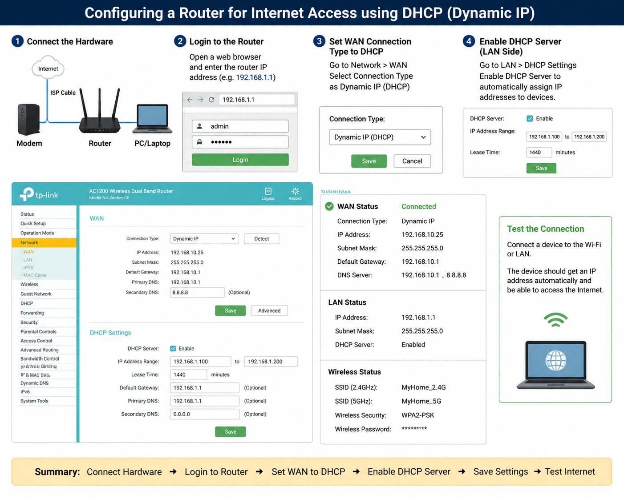
Configuring a Router for Internet Access using DHCP
- Connect Hardware
Connect the ISP cable to the WAN port of the router and connect your PC/laptop to the router (via Wi-Fi or Ethernet).
- Access Router Settings
Open a web browser and enter the router IP (e.g., 192.168.1.1). Log in using admin credentials.
- Configure WAN Settings
Go to Network/WAN settings and select Dynamic IP (DHCP) as the connection type.
The router will automatically receive IP address, gateway, and DNS from the ISP.
- Enable DHCP Server (LAN Side)
Turn on DHCP so the router can assign IP addresses automatically to connected devices (e.g., 192.168.1.100–192.168.1.200).
- Save and Apply
Save settings and reboot the router if required.
- Test Connection
Connect a device and verify that it gets an IP automatically and can access the internet.

Section 5: Essay

10. Discuss the importance of network documentation in the context of building and managing networks.
Ans.
Network documentation is a structured record of all details related to a network, including its design, devices, configurations, IP addresses, and security settings. It is essential for both setting up and managing a network efficiently.
It provides a clear blueprint of the entire network, helping administrators understand how everything is connected. This reduces confusion and ensures correct setup during the building phase.
During operation, it makes troubleshooting much faster, as admins can quickly locate faults without trial and error. It also supports smooth maintenance and upgrades, since existing configurations are already documented, reducing the risk of mistakes.
From a security perspective, it helps in tracking policies, permissions, and vulnerabilities, making it easier to enforce protection measures and respond to threats.
Additionally, it improves communication and teamwork, especially in organizations where multiple people manage the network. New team members can easily learn the system using documentation.
In case of failures, disasters, or cyberattacks, documentation enables quick recovery and backup restoration, minimizing downtime.
Overall, network documentation ensures the network is well-organized, scalable, secure, and easy to manage over time.

